TASK - 7
02-07-2026

TOPIC :Add User to the group and Login Permission

1) Login AWS account and Start the Instance is running connect to the server

Command for connect:
ssh -i "kittu.pem" ubuntu@ec2-18-212-76-2.compute-1.amazonaws.com

2) Create user and group

Command for add user: sudo adduser username
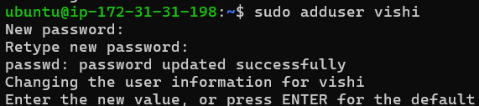

Command for add group :sudo addgroup groupname

3) To add user into the group
Command: sudo usermod -aG groupname username
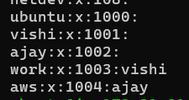
While adding user into the group want to enter the groupname 1st then username 2nd
-a — means then adding
G — group

4) To deleting user from the group
Command: sudo gpasswd -d username groupname
While adding user into the group want to enter the username 1st then groupname 2nd
g — group
passwd — user
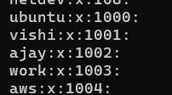

5) To create the file and write code in terminal
Commands create the file: sudo touch file name
sudo vi file name
After enter the commands want to Click “I” for insert it then write code and press the ESC

Commands for save the code:
:wq! << The command is used for save the code
:q! << The command is used for save the code without changes

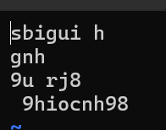 written the code and i use command :q!

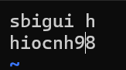The written code will not save

By using the command :wq! It will save the full code

LOGIN PERMISSION

- Connect ubuntu server enter the Commands

cd /
cd /etc/ssh
Ls << To see list of files

- After that change the permission
Command : sudo vi sshd_config
After the using the command want to give the permission
In terminal change the permission of the
#publickey authentication is have # symbol remove the # symbol and click “ESC” and Enter the Command:
:wq! <<< The Command for save the change
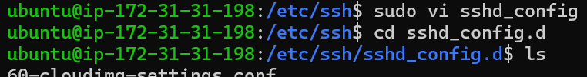

- Enter the command
cd sshd_config.d
ls

- After the Enter the ls command it will show like “60-cloudimg-settings.conf” copy it
- Then Enter the command : sudo vi “paste the copied one”
After that it will ask permission like this frist it have the permission like “NO” want to change it as “YES”
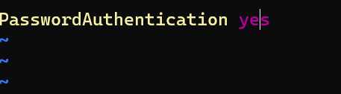
Press the “ESC”
And Enter the command :wq! It will save change

- After the completing want restart it
Command : “sudo systemctl restart ssh”

LOGIN IN USER

- Create the user
Command <<< “sudo adduser username”
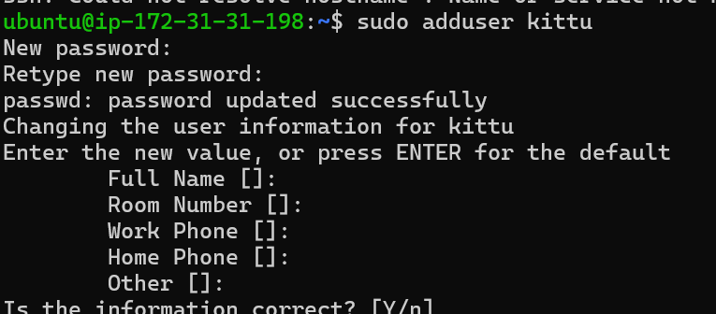

- Copy the Public ip address from the Instance



- Enter the command

“ssh kittu@public ip address”

Then it will ask permission enter “YES”
After it will ask password “ENTER PASSWORD”

- The new user will logged in



